Community/Honour
Quotation | Explanation
‘And now we are quite civilized, quite American’ (p. 4)

‘The man would be honoured to lend me a place to sleep’ (p. 8)

‘I want you to be with a different class of people …’ (p. 10)

‘The kid snitched?’ (p. 13)

‘They spit on him in the street, his own father and his brothers. The whole neighbourhood was cryin’’ (p. 14)

‘That blond one though … he’s got a sense of humour” (p. 25)

‘You won’t have a friend in the world, Eddie. Even those who understand will turn against you.’ (p. 49)

‘That one! I accuse that one!’ (p. 57)

‘Wipin’ the neighbourhood with my name like a dirty rag! I want my name Marco’ (p. 63)

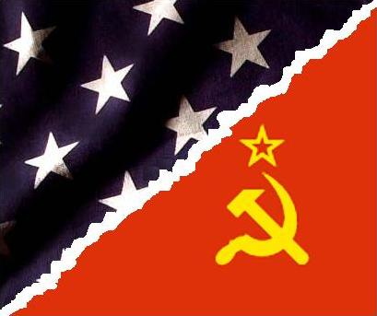
How is the historical context important to the theme of community/honour?

Which main events do you associate with the theme of community/honour?

Which characters do you associate with the theme of community/honour?

