The staging of the play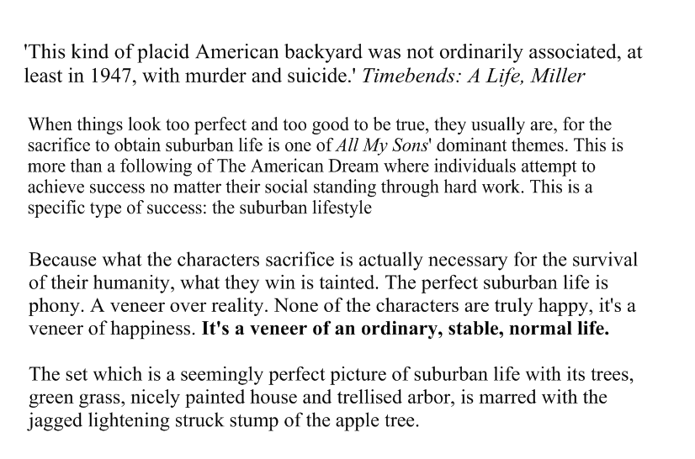
In America, back yards are not meant to be 'private'. Neighbours are able to move about freely, and the Kellers show this with their symbolic community atmosphere.

The community settings emphasises the human and social aspect of Keller's crimes.

The problems of a family and their neighbours emphasises Miller's message that everyone must look after each other. Community and support is essential.

Why is it set in August?

It is high summer, the apogee of the year. Ahead lies the fall. In the garden are plants “whose season is gone”. Ahead, in other words, lies a bleaker time. And since the play is described as taking place in “August of our era” this is a play about America, also at a point of balance, emerging from an idealistic period into something more crassly material and self-interested. The action takes place over a few hours but it does so as bright day gives way to sunset which in turn gives way to the small hours of the morning in which all colour is bleached from the set as from the lives of those who inhabit it.
The oppressive and hermetic atmosphere traps this family behind a row of trees in their own past. The static nature of the set reflects lives which have been arrested. This is not a family that can yet accept that they live in a world of consequences, in which past events have present results.

