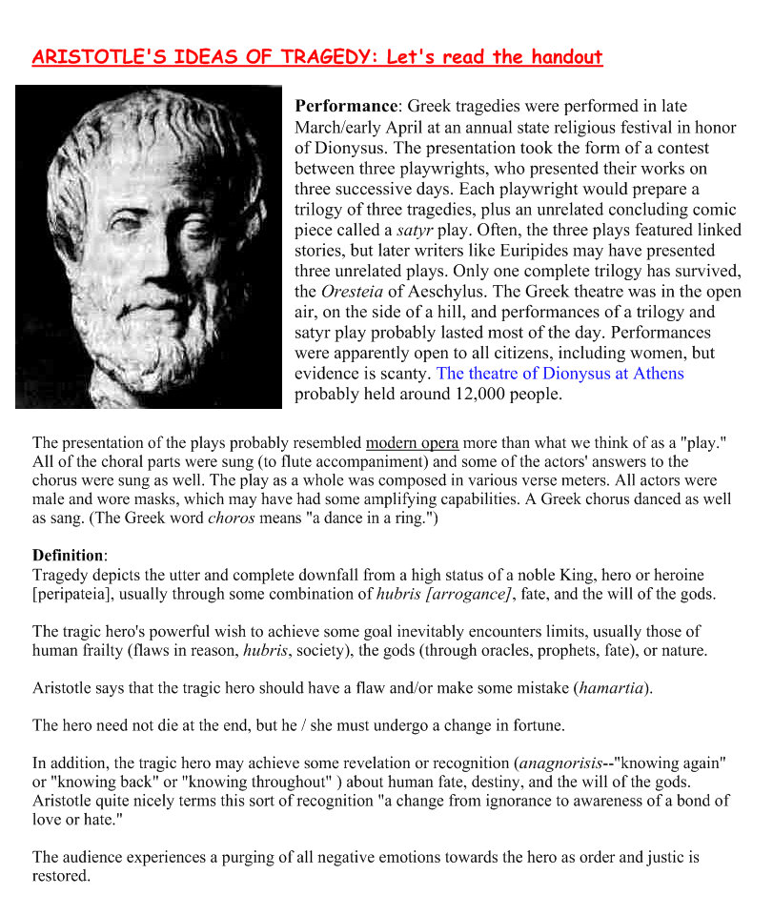
- “I think the tragic feeling is evoked in us when we are in the presence of a character who is ready to lay down his life, if need be, to secure one thing—his sense of personal dignity. From Orestes to Hamlet, Medea to Macbeth, the underlying struggle is that of the individual attempting to gain his ‘rightful’ position in his society.” —Arthur Miller

- The Greek overtones in Miller’s work have been the subject of countless high school English essays and graduate dissertations. Whether it is Joe Keller in All My Sons Willy Loman in Death of a Salesman or Eddie Carbone in A View from the Bridge, Miller’s uncompromising exploration of human mistake and regret is at the core of his literary genius. These men, though unforgivable in their sins and failures, are as sympathetic as they are flawed.
In the Greek tragedies of Sophocles, Aeschylus and Euripides (and later in those of Shakespeare), the tragic hero is marked by a fatal flaw (usually hubris, or arrogance), which compels him to commit a grave and irrevocable error. The hero then descends into a journey marked by denial, suffering and isolation, only after which does he realize that death is the only possible course. Only with the tragic hero gone can moral order be restored, and with that death also comes freedom for all other entangled characters.
However, drawing parallels between Miller’s two most famous protagonists, Willy Loman and Joe Keller, is tricky business. Joe Keller is a pillar among men—beloved by the town in which he lives, the boss of a powerful business, a success by all measurable accounts. This is no Willy Loman, accustomed to failure and rejection. Though both men follow a similar trajectory and certainly share a similar end, Keller is more similar to the kings of Greek tragedy than his weak literary counterpart.

- “All My Sons contains elements of Greek tragedy not only in its retroactive structures but also in a story that at times evokes Aeschylus’s Oresteia and Sophocles’ Oedipus Rex. Joe Keller can be viewed as a king whose hands are stained with a son’s blood, and Kate Keller as a Queen who is suspended between shielding her husband and destroying him for love of a son. … The Oedipal theme is carried further in Chris’s behavior toward his parents and the terrifying mix of love, protection and vengeance in Mrs. Keller. Likewise Ann, George and their absent father might be viewed as the opposite of the Kellers, an ill-used and wrongfully deposed royal family of three; in their own way they are similar to Ophelia, Laertes and Polonius of Hamlet, another play with Greek overtones.”
— “Arthur Miller: His Life and Work,” by Martin Gottfried

- Joe Keller ought to be the hero-villain of All My Sons, since pragmatically he certainly is a villain. But Miller is enormously fond of Joe, and so are we; he is not a good man, and yet he lives like, one, in regard to family, friends, neighbors. I do not think that Miller ever is interested in Hannah Arendt’s curious notion of the banality of evil. Joe is banal, and he is not evil though his business has led him into what must be called moral idiocy, in regard to his partner and to any world that transcends his own immediate family. Poor Joe is just not very intelligent, and it is Miller’s curious gift that he can render such a man dramatically interesting. An ordinary man who wants to have a moderately good time, who wants his family never to suffer, and who lacks any imagination beyond the immediate: what is this except an authentic American Everyman?
Harold Bloom, "Introduction," Arthur Miller’s All My Sons, Modern Critical Interpretations,
1988

Miller’s protagonists, at once both complex and contradictory, are most often male and traditionally carry the moral burden of the play. Their suffering, sacrifice, and deliberate acts of passive resistance are presented as ideals with which the audience is meant to identify and respect. Miller crafts his characters to attain their allotment of personal heroism only through the acceptance of their social guilt. Each man’s tragedy ultimately reveals itself as a loss of private honor in the face of a more public responsibility. Stefani Koorey, "Introduction," Arthur Miller’s Life and Literature: An Annotated and Comprehensive Guide, 2000

